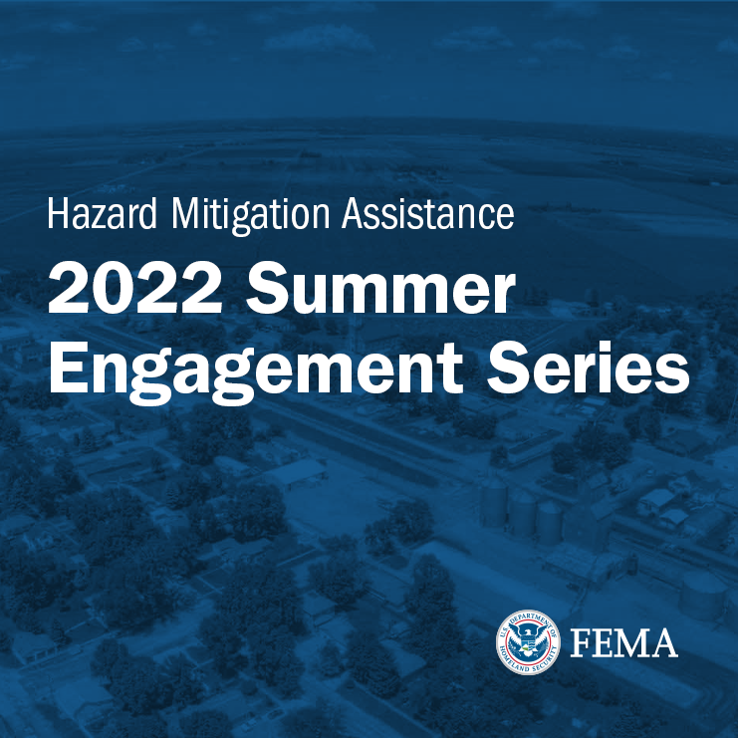

Register now for the 2022 Hazard Mitigation Assistance Summer Engage-ment Series. This multi-part webinar series will bring FEMA subject-matter experts and partners together to provide technical information, best practices, tools, and resources regarding the HMA grant programs. All sessions will be recorded. The link to recordings will be provided when available.
Webinar Series Schedule
Aug 18, 2022 2:00 p.m. EST - Aug 18, 2022 3:30 p.m. EST
Virtual
System-Based Mitigation: Building Enduring Community Resilience
This webinar will discuss the concept of building community resilience at a “systems” level.

Aug 19, 2022 2:00 p.m. EST - Aug 19, 2022 3:30 p.m. EST
Virtual
Mitigating Severe Repetitive Loss and Repetitive Loss Properties
This webinar will discuss funding available through FEMA’s Fiscal Year 2022 Flood Mitigation Assistance grant program to mitigate repetitively flood damaged buildings insured under the National Flood Insurance Program.

Aug 23, 2022 4:00 p.m. EST - Aug 23, 2022 5:30 p.m. EST

Virtual
BRIC/FMA Notice of Funding Opportunity Webinar
This webinar will be the first review of the fiscal year 2022 Notices of Funding Opportunity (NOFOs) for BRIC and FMA.

Aug 25, 2022 2:00 p.m. EST - Aug 25, 2022 3:30 p.m. EST

Virtual
Application Pitfalls
This webinar will address common grant application errors and how to avoid them in the Building Resilient Infrastructure and Communities (BRIC) and Flood Mitigation Assistance (FMA) grant programs.

Sep 1, 2022 2:00 p.m. EST - Sep 1, 2022 3:30 p.m. EST

Virtual
BRIC/FMA Notice of Funding Opportunity Webinar
This webinar will be a review of the fiscal year 2022 Notices of Funding Opportunity (NOFOs) for BRIC and FMA.

Sep 15, 2022 4:00 p.m. EST - Sep 15, 2022 5:30 p.m. EST
Virtual
BRIC/FMA Notice of Funding Opportunity Webinar: Tribal
This webinar will be a review of the fiscal year 2022 Notices of Funding Opportunity for BRIC. The content will be tailored to tribal applicants.

Sep 22, 2022 2:00 p.m. EST - Sep 22, 2022 3:30 p.m. EST
Virtual
BRIC FY 2022 Notice of Funding Opportunity Technical and Qualitative Criteria
This webinar will provide an overview and information about the Fiscal Year (FY) 2022 BRIC Technical and Qualitative Criteria, as outlined in the Notice of Funding Opportunity.

Sep 29, 2022 2:00 p.m. EST - Sep 29, 2022 3:30 p.m. EST
Virtual
Environmental Historic Preservation Review 101
This webinar will provide details on how communities should factor in environmental historic preservation, regulations, executive orders, and laws when planning projects.

Oct 4, 2022 2:00 p.m. EST - Oct 4, 2022 3:30 p.m. EST

Virtual
Using Grant Funding to Build Resilience: The How, When, and Where of Applying for the Hazard Mitigation Grant Program (HMGP)
This webinar will provide information and an overview to applicants and subapplicants on how to develop and submit applications for FEMA’s Hazard Mitigation Grant Program (HMGP), which includes the HMGP Post Fire program.

