State of Florida

Emergency Responder Qualification

ESF 6 Mass Care

Job Titles
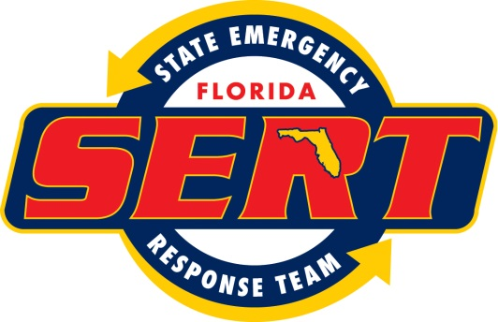
State Emergency Response Team
MARCH 2014
Table of Contents

ESF 6 Job Titles

1. Deputy ESF 6 Coordinator 4
2. State ESF 6 Resource Unit Leader 5
3. State ESF 6 Situation Unit Leader 6
4. ESF 6 State Agency Representative 7
Introduction

This document describes criteria for ESF 6 positions within the State Emergency Response Team. The State Emergency Response Team determined the Job Titles listed herein to be the most common ESF 6 Mass Care & Emergency Assistance job positions required in the state emergency response center.

Category Definitions

Education | Formal instruction based on a curriculum that prepares an individual with the core knowledge and skill for entry into a discipline and for performing a job function
Training | Instruction and/or activities that enhance an individual’s core knowledge, increase skill set and proficiency, and strengthen and augment abilities.
Experience | Time required in a job function for an individual to attain proficiency in applying knowledge, skills, and abilities
Physical/Medical Fitness | Physical and medical considerations that when applied, help ensure safe performance in potentially hazardous environments.
Currency | Performing in a specific incident management position during a qualifying incident, approved exercise, drill, training or simulation at least once every five years.

1. Deputy ESF 6 Coordinator
Description: | The Deputy ESF 6 Coordinator is responsible for the conduct of ESF 6 EOC Operations and is the central coordination point for ESF 6 within the State EOC. This position coordinates with the NGO representatives, supervises the activities in the adjacent ESF 6 Breakout Room and responds to requests from the Human Services Branch Director.
Training: |  | Completion of the following courses/curricula:  - ICS-100: Introduction to ICS.  - ICS-200: Basic ICS.  - ICS-300: Intermediate  - ICS-400: Advanced  - IS-700.A: NIMS, An Introduction.  - IS-800.B: NRF, An Introduction.  - IS-775 EOC Management and Operations  - IS 806 Mass Care, Emergency Assistance, Housing, and Human Services  - Training on American Red Cross National Shelter System (NSS).  - State emergency operations center procedures
Experience: |  | Knowledge, Skills and Abilities:  - Knowledge of emergency response planning.  - General operational knowledge of logistical support systems or procedures  Experience:  Operational experience in an Emergency Operation Center (EOC).
Currency: |  | Qualifying incident experience, exercises, drills or simulations every 5 years.

2. State ESF 6 Resource Unit Leader
Description: | The Resource Unit Leader is responsible for coordinating mission requests and resource requests.
Training: |  | Completion of the following courses/curricula:  - ICS-100: Introduction to ICS.  - ICS-200: Basic ICS.  - IS-700.A: NIMS, An Introduction.  - IS-800.B: NRF, An Introduction.  - State emergency operations center procedures
Experience: |  | - Operational experience at a state emergency operations center.  - Has some knowledge of the role of voluntary agencies in delivering mass care during an incident.
Currency: |  | Qualifying incident experience, exercises, drills or simulations every 5 years.

3. State ESF 6 Situation Unit Leader
Description: | The Situation Unit Leader collects, analyzes and disseminates incident information according to prescribed reports and procedures.
Training: |  | Completion of the following courses/curricula:  - ICS-100: Introduction to ICS.  - ICS-200: Basic ICS.  - IS-700.A: NIMS, An Introduction.  - IS-800.B: NRF, An Introduction.  - State emergency operations center procedures
Experience: |  | - Operational experience at a state emergency operations center.  - Some knowledge of the role of voluntary agencies in delivering mass care during an incident.
Currency: |  | Qualifying incident experience, exercises, drills or simulations every 5 years.

4. ESF 6 State Agency Representative
Description: | The State Agency Representative assumes the role of Agency Representative and coordinates Agency tasks specified in the Comprehensive Emergency Management Plan.
Training: | Completion of the following courses/curricula:  - ICS-100: Introduction to ICS.  - ICS-200: Basic ICS.  - IS-700.A: NIMS, An Introduction.  - IS-800.B: NRF, An Introduction.  - State emergency operations center procedures
Experience: | - Knowledge of parent agency roles and responsibilities in a disaster.
Currency: | Qualifying incident experience, exercises, drills or simulations every 5 years.

