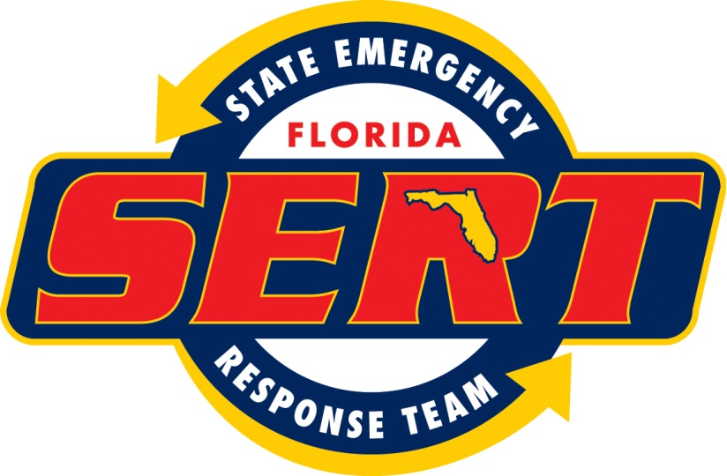

Task Book: Employee Job Aid

**State Emergency Response Team**

Human Services Branch

ESF 6, Mass Care

## Position: ESF 6 Resource Unit Leader

Date: *March 2014*

**Position Task Book: Purpose**

Position task books have been developed for positions within the State Emergency Response Team. Each task book lists the essential tasks for the specific position.

Task books are designed to:

1. Describe the tasks to be performed for a given position.
2. Determine training needs of individual employees.
3. Serve as a tool for promoting task-related performance feedback throughout an activation.
4. Record performance assessment data.

At the completion of an activation, your supervisor will identify the tasks you were able to perform and the tasks needing improvement.

**Responsibilities**

Listed below are the responsibilities associated with completion of this position task book.

The **Individual Employee** is responsible for:

1. Reviewing and understanding instructions in this task book.
2. Identifying desired objectives/goals related to the assigned tasks and subtasks.
3. Providing background information to the supervisor.
4. Demonstrating the ability to perform all tasks and subtasks for an assigned position.
5. Working with the supervisor to improve performance as needed.

The **Supervisor** is responsible for:

1. Being qualified and proficient in the position being evaluated or seeking technical assistance from someone who is qualified.
2. Meeting with the individual employee and determining past experience, current qualifications, and desired objectives/goals.
3. Reviewing task and subtask expectations with the individual employee.
4. Explaining to the individual employee the evaluation procedures that will be used.
5. Accurately evaluating and recording demonstrated performance of tasks and subtasks.
6. Providing constructive feedback to the employee.
7. Suggesting steps for improving performance as needed.

ESF 6, Mass Care

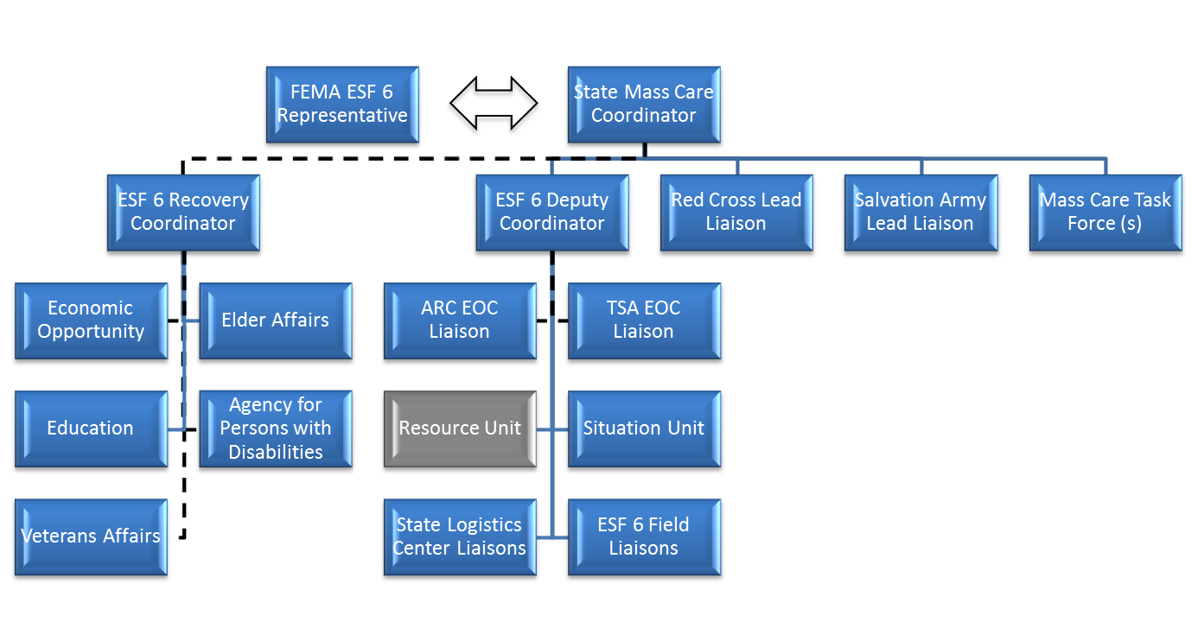

**Competency 1: Assume position responsibilities**

*Description: Successfully assume role of ESF 6 Resource Unit Leader and initiate position activities at the appropriate time according to the following behaviors.*

**Behavior 1**: Ensure readiness for assignment.

|  |
| --- |
| **Tasks** |
| 1. Carry an electronic device that allows rapid response to alerts by the State Watch Office. 2. Arrive at the State Emergency Operations Center within one hour of an alert call |

**Behavior 2:** Ensure availability, qualifications and capabilities of resources to complete assignment.

|  |
| --- |
| **Tasks** |
| 1. Assist Deputy ESF 6 Coordinator in notifying additional staff, voluntary agency liaisons, or state agency liaisons, if their presence is required and request that they report to the State Emergency Operations Center. 2. Verify that ESF 6 telephones and computer equipment are operationally ready and take action to correct any deficiencies. |

**Behavior 3:** Gather, update and apply situational information relevant to the assignment

|  |
| --- |
| **Tasks** |
| 1. Gather information necessary to assess the incident and determine immediate needs and actions.    * Type of incident (natural disaster or terrorism)    * Weather    * County requests for mass care or emergency assistance    * Size and density of population affected    * Extent and expected duration of loss of electrical power    * Number of shelters open and their populations    * Existence or likelihood of evacuations    * Existence or likelihood of host community operations    * Size and characteristics of vulnerable populations in the affected area 2. Obtain briefing from Deputy ESF 6 Coordinator    * Summary of incident, current activity and anticipated unit activity.    * Receive Deputy ESF 6 Coordinator’s priorities, goals and objectives for ESF 6. 3. Review current and previous state and county situation reports. |

**Behavior 4:** Establish effective relationships with relevant personnel

|  |
| --- |
| **Tasks** |
| 1. Establish and maintain positive interpersonal and interagency working relationships.    * Voluntary Agency liaisons    * State Agency liaisons    * ESF 6 staff    * State Emergency Operations Center staff 2. Create a work environment that provides mutual respect and equal opportunity for all personnel assigned to the incident. |

**Behavior 5**: Establish organizational structure, reporting procedures and chain of command of assigned resources

|  |
| --- |
| **Tasks** |
| 1. Plan and activate the Resource Unit organization.    * Identify personnel/equipment within the organization to be activated and the resources required for activation.    * Brief Deputy Resource Unit Leader including summary of incident, current activity and anticipated unit activity.    * Provide initial operating instructions to organization personnel, including safety and security concerns and expectations. 2. Supervise and adjust Resource Unit as needed, based on changes in the incident situation and resource status.    * Ensure that incident and ESF 6 tasks are communicated to all organization personnel.    * Ensure that any changes in priorities are communicated and understood.    * Ensure effective use and coordination of all assigned personnel.    * Maintain appropriate span of control. |

**Behavior 6**: Understand and comply with ICS concepts and principles

|  |
| --- |
| **Tasks** |
| 1. Maintain appropriate span of control. 2. Demonstrate knowledge of ICS structure, principles and positions. 3. Understand scope, roles, responsibilities, jurisdiction, and authority of responder agencies. 4. Assure execution of appropriate administrative requirements. |

**Competency 2: Lead assigned personnel**

*Description: Influence, guide and direct assigned personnel to accomplish objectives and desired outcomes in a rapidly changing, high-risk environment.*

**Behavior 1**: Model leadership values and principles

|  |
| --- |
| **Tasks** |
| 1. Exhibit principles of duty.  * Be proficient in your job, both technically and as a leader. * Make sound and timely decisions. * Ensure that tasks are understood, supervised and accomplished. * Develop your subordinates for the future.  1. Exhibit principles of respect.  * Know your subordinates and look out for their well-being. * Keep your subordinates informed. * Build the team. * Employ your subordinates in accordance with their capabilities.  1. Exhibit principles of integrity.  * Know yourself and seek improvement. * Seek responsibility and accept responsibility for your actions. * Set the example. |

**Behavior 2:** Ensure the safety, welfare and accountability of assigned personnel

|  |
| --- |
| **Tasks** |
| 1. Recognize potentially hazardous situations. 2. Inform subordinates of hazards. 3. Control positions and functions of resources. 4. Ensure that special precautions are taken when extraordinary hazards exist. 5. Ensure adequate rest is provided to all unit personnel. 6. Provide and support a hostile-free work environment. 7. Comply with agency safety requirements. |

**Behavior 3**: Establish work assignments and performance expectations, monitor performance and provide feedback

|  |
| --- |
| **Tasks** |
| 1. Direct and coordinate Resource Unit personnel.  * Assign responsibility for areas or functions. * Ensure they are aware of meetings, briefings and conference call times * Use interim ICS positions if complexity or span of control indicates need.  1. Continuously evaluate performance. 2. Communicate deficiencies immediately and take corrective action. 3. Assign resources according to incident priorities. 4. Direct changes in personnel and resources based on the progression of the incident. |

**Behavior 4:** Emphasize Teamwork

|  |
| --- |
| **Tasks** |
| 1. Recognize group performance that supports the team meeting incident objectives. |

**Behavior 5**: Coordinate interdependent activities

|  |
| --- |
| **Tasks** |
| 1. Interact and coordinate with key partners.  * Human Services Branch * Unified Logistics * Recovery * Voluntary agencies * State agencies * ESF 6 Situation Unit Leader |

**Competency 3: Communicate effectively**

*Description: Use suitable communications techniques to share relevant information with appropriate personnel on a timely basis to accomplish objectives in a rapidly changing, high-risk environment.*

**Behavior 1**: Ensure relevant information is exchanged during briefings and debriefings

|  |
| --- |
| **Tasks** |
| 1. Obtain briefing from Deputy ESF 6 Coordinator.  * Summary of incident, current activity and anticipated unit activity. * Receive Deputy ESF 6 Coordinator’s priorities, goals and objectives for ESF 6. * Receive special instructions.  1. Conduct briefing to the state Emergency Operations Center on the activities of ESF 6, when directed. 2. Use ESF 6 Incident Action Plan board to brief and keep unit leaders/liaisons informed. Update the following items on the board daily:  * Personnel assignments. * State Emergency Response Team mass care & emergency assistance objectives. * ESF 6 tasks. * Future staffing. * Times for conference calls, meetings & briefings |

**Behavior 2**: Ensure documentation is complete and disposition is appropriate

|  |
| --- |
| **Tasks** |
| 1. Ensure that missions assigned to ESF 6 are responded to and updated according to established guidelines. 2. Ensure that all personnel time records documenting ESF 6 participation are completed and filed according to established guidelines. 3. Ensure that all ESF 6 related disaster purchases are documented according to established guidelines. |

**Behavior 3**: Gather, produce and distribute information as required by established guidelines and ensure understanding by recipients

|  |
| --- |
| **Tasks** |
| 1. Ensure that the state shelter information is current and available on the designated website. |

**Behavior 4**: Communicate and ensure understanding of work expectations within the chain of command and across functional areas

|  |
| --- |
| **Tasks** |
| 1. Evaluate and share with Resource Unit members, all information for ESF 6 and what is anticipated for incident operations based on expected duration, size, and type of incident. |

**Behavior 5**: Develop and implement plans and gain concurrence of affected agencies and/or the public

|  |
| --- |
| **Tasks** |
| 1. Collect information at the daily mass care conference call. 2. Collect information and conduct briefing, if required, at the daily Human Services Branch meeting. |

**Competency 4: Ensure completion of assigned actions to meet identified objectives**

*Description: Identify, analyze and apply relevant situational information and evaluate actions to complete assignments safely and meet identified objectives. Complete actions within established timeframe.*

**Behavior 1**: Administer and/or apply agency policy, contracts and agreements

|  |
| --- |
| **Tasks** |
| 1. Assist Deputy ESF 6 Coordinator in ensuring all applicable agencies’ policies, contracts, and agreements are followed.  * State Comprehensive Emergency Management Plan ESF 6 Mass Care, Emergency Assistance & Human Services Annex * ESF 6 Standard Operating Guidelines * State Multi-Agency Feeding Plan * State Shelter Support Plan * State Emergency Operations Center policies and procedures * Voluntary agencies policies and procedures * ESF 6 Supporting agencies policies and procedures |

**Behavior 2:** Gather, analyze and validate information pertinent to the incident or event and make recommendations for setting priorities

|  |
| --- |
| **Tasks** |
| 1. Assist Deputy ESF 6 Coordinator in estimating the scale of the disaster.  * Type of incident (natural disaster or terrorism) * Size of geographical area affected. * Size and density of population affected * Extent and expected duration of loss of electrical power * Weather * Existence or likelihood of evacuations * Existence or likelihood of host community operations * Size and characteristics of vulnerable populations in the affected area |

**Behavior 3:** Utilize information to produce outputs

|  |
| --- |
| **Tasks** |
| 1. Ensure state shelter data is current and reflected on the state web site. |

**Behavior 4:** Take appropriate action based on assessed risks

|  |
| --- |
| **Tasks** |
| 1. Use established state emergency operations center coordination protocols and procedures to respond to requests for mass care/emergency assistance from state agencies or counties    * Coordinate with voluntary agency liaisons at the state emergency operations to determine their availability to comply with the request.    * Follow up on the actions of the voluntary agency to ensure that the needs of the requestor have been met. 2. When directed by Deputy ESF 6 Coordinator, use established state emergency operations center coordination protocols and procedures to request logistical support for mass care/emergency assistance activities.    * Establish deadlines to the voluntary agencies for submission of logistical requirements.    * Plan for 48 hours from time of request to actual delivery of logistical resource to requested location. 3. When directed by Deputy ESF 6 Coordinator, prepare and submit a federal Action Request Form for resources that cannot be met by the state.    * Quantify required mass care/emergency assistance resources by type and kind.    * Verify that requested resource is not available from state agencies.    * Coordinate request with the FEMA ESF 6 liaison at the state emergency operations center and/or the FEMA ESF 6 representative at the FEMA Regional office    * Coordinate reporting date, time and location of requested resources    * Use established state emergency operations center coordination protocols and procedures to produce and submit a FEMA Action Request Form to the State Coordinating Officer for approval    * Follow up on status of request 4. When directed by Deputy ESF 6 Coordinator, prepare and submit an Emergency Management Assistance Compact request for resources that cannot be met by the state.    * Quantify required mass care/emergency assistance resources by type and kind    * Verify that requested resource is not available from state agencies.    * Coordinate reporting date, time and location of requested resources    * Use established state emergency operations center coordination protocols and procedures to request resources through the Emergency Management Assistance Compact    * Follow up on status of request |

**Behavior 5:** Modify approach based on evaluation of incident situation

|  |
| --- |
| **Tasks** |
| 1. Maintain situational awareness.    * Seek out Deputy ESF 6 Coordinator for situational updates.    * Read county and voluntary agency situation reports    * Monitor requests for mass care support    * When directed by Deputy ESF 6 Coordinator, seek out verbal updates from ESF 8, Health & Medical |

**Behavior 6**: Plan for demobilization and ensure demobilization procedures are followed

|  |
| --- |
| **Tasks** |
| 1. When directed by Deputy ESF 6 Coordinator, establish demobilization and/or transition procedures.    * Coordinate demobilization/transition plan with voluntary and state agency partners.    * Receive approval from Deputy ESF 6 Coordinator on demobilization/transition plan before dissemination. 2. Ensure demobilization of voluntary agency resources are coordinated in a timely manner with affected local governments. 3. Demobilize incident resources by predetermined priorities or as work progress dictates.    * Priorities are coordinated, when appropriate, during the mass care conference call.    * Priorities for demobilization of feeding resources are specified in the Multi-agency Feeding Plan. |

THIS PAGE INTENTIONALLY LEFT BLANK



Task Book: Employee Job Aid

**State Emergency Response Team**

Human Services Branch

ESF 6, Mass Care

## Position: ESF 6 Situation Unit Leader

Date: March 2014

**Position Task Book: Purpose**

Position task books have been developed for positions within the State Emergency Response Team. Each task book lists the essential tasks for the specific position.

Task books are designed to:

1. Describe the tasks to be performed for a given position.
2. Determine training needs of individual employees.
3. Serve as a tool for promoting task-related performance feedback throughout an activation.
4. Record performance assessment data.

At the completion of an activation, your supervisor will identify the tasks you were able to perform and the tasks needing improvement.

**Responsibilities**

Listed below are the responsibilities associated with completion of this position task book.

The **Individual Employee** is responsible for:

1. Reviewing and understanding instructions in this task book.
2. Identifying desired objectives/goals related to the assigned tasks and subtasks.
3. Providing background information to the supervisor.
4. Demonstrating the ability to perform all tasks and subtasks for an assigned position.
5. Working with the supervisor to improve performance as needed.

The **Supervisor** is responsible for:

1. Being qualified and proficient in the position being evaluated or seeking technical assistance from someone who is qualified.
2. Meeting with the individual employee and determining past experience, current qualifications, and desired objectives/goals.
3. Reviewing task and subtask expectations with the individual employee.
4. Explaining to the individual employee the evaluation procedures that will be used.
5. Accurately evaluating and recording demonstrated performance of tasks and subtasks.
6. Providing constructive feedback to the employee.
7. Suggesting steps for improving performance as needed.

ESF 6, Mass Care

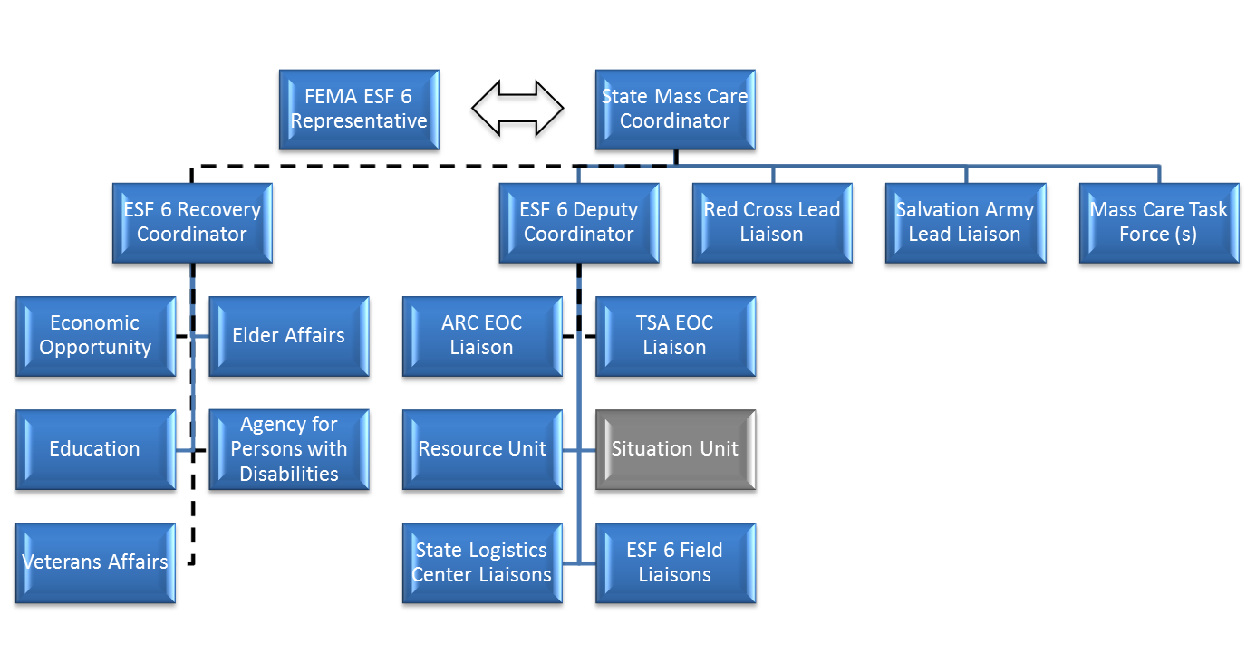

**Competency 1: Assume position responsibilities**

*Description: Successfully assume role of ESF 6 Situation Unit Leader and initiate position activities at the appropriate time according to the following behaviors.*

**Behavior 1:** Ensure readiness for assignment.

|  |
| --- |
| **Tasks** |
| 1. Carry an electronic device that allows rapid response to alerts by the State Watch Office. 2. Arrive at the State Emergency Operations Center within one hour of an alert call |

**Behavior 2:** Ensure availability, qualifications and capabilities of resources to complete assignment.

|  |
| --- |
| **Tasks** |
| 1. Assist Deputy ESF 6 Coordinator in notifying additional staff, voluntary agency liaisons, or state agency liaisons, if their presence is required and request that they report to the State Emergency Operations Center. 2. Verify that ESF 6 telephones and computer equipment are operationally ready and take action to correct any deficiencies. |

**Behavior 3**: Gather, update and apply situational information relevant to the assignment

|  |
| --- |
| **Tasks** |
| 1. Gather information necessary to assess the incident and determine immediate needs and actions.    * Type of incident (natural disaster or terrorism)    * Weather    * County requests for mass care or emergency assistance    * Size and density of population affected    * Extent and expected duration of loss of electrical power    * Number of shelters open and their populations    * Existence or likelihood of evacuations    * Existence or likelihood of host community operations    * Size and characteristics of vulnerable populations in the affected area 2. Obtain briefing from Deputy ESF 6 Coordinator    * Summary of incident, current activity and anticipated unit activity.    * Receive Deputy ESF 6 Coordinator’s priorities, goals and objectives for ESF 6. 3. Review current and previous state and county situation reports. |

**Behavior 4:** Establish effective relationships with relevant personnel

|  |
| --- |
| **Tasks** |
| 1. Establish and maintain positive interpersonal and interagency working relationships.    * Voluntary Agency liaisons    * State Agency liaisons    * ESF 6 staff    * State Emergency Operations Center staff 2. Create a work environment that provides mutual respect and equal opportunity for all personnel assigned to the incident. |

**Behavior 5**: Establish organizational structure, reporting procedures and chain of command of assigned resources

|  |
| --- |
| **Tasks** |
| 1. Plan and activate the Situation Unit organization.    * Identify personnel/equipment within the organization to be activated and the resources required for activation.    * Brief Deputy Situation Unit Leader including summary of incident, current activity and anticipated unit activity.    * Provide initial operating instructions to organization personnel, including safety and security concerns and expectations. 2. Supervise and adjust Situation Unit as needed, based on changes in the incident situation and resource status.    * Ensure that incident and ESF 6 tasks are communicated to all organization personnel.    * Ensure that any changes in priorities are communicated and understood.    * Ensure effective use and coordination of all assigned personnel.    * Maintain appropriate span of control. |

**Behavior 6:** Understand and comply with ICS concepts and principles

|  |
| --- |
| **Tasks** |
| 1. Maintain appropriate span of control. 2. Demonstrate knowledge of ICS structure, principles and positions. 3. Understand scope, roles, responsibilities, jurisdiction, and authority of responder agencies. 4. Assure execution of appropriate administrative requirements. |

**Competency 2: Lead assigned personnel**

*Description: Influence, guide and direct assigned personnel to accomplish objectives and desired outcomes in a rapidly changing, high-risk environment.*

**Behavior 1:** Model leadership values and principles

|  |
| --- |
| **Tasks** |
| 1. Exhibit principles of duty.  * Be proficient in your job, both technically and as a leader. * Make sound and timely decisions. * Ensure that tasks are understood, supervised and accomplished. * Develop your subordinates for the future.  1. Exhibit principles of respect.  * Know your subordinates and look out for their well-being. * Keep your subordinates informed. * Build the team. * Employ your subordinates in accordance with their capabilities.  1. Exhibit principles of integrity.  * Know yourself and seek improvement. * Seek responsibility and accept responsibility for your actions. * Set the example. |

**Behavior 2**: Ensure the safety, welfare and accountability of assigned personnel

|  |
| --- |
| **Tasks** |
| 1. Recognize potentially hazardous situations. 2. Inform subordinates of hazards. 3. Control positions and functions of resources. 4. Ensure that special precautions are taken when extraordinary hazards exist. 5. Ensure adequate rest is provided to all unit personnel. 6. Provide and support a hostile-free work environment. 7. Comply with agency safety requirements. |

**Behavior 3**: Establish work assignments and performance expectations, monitor performance and provide feedback

|  |
| --- |
| **Tasks** |
| 1. Direct and coordinate Situation Unit personnel.  * Assign responsibility for areas or functions. * Ensure they are aware of meetings, briefings and conference call times * Use interim ICS positions if complexity or span of control indicates need.  1. Continuously evaluate performance. 2. Communicate deficiencies immediately and take corrective action. 3. Assign resources according to incident priorities. 4. Direct changes in personnel and resources based on the progression of the incident. |

**Behavior 4**: Emphasize Teamwork

|  |
| --- |
| **Tasks** |
| 1. Recognize group performance that supports the team meeting incident objectives. |

**Behavior 5**: Coordinate interdependent activities

|  |
| --- |
| **Tasks** |
| 1. Interact and coordinate with key partners.  * Human Services Branch * Unified Logistics * Recovery * Voluntary agencies * State agencies * ESF 6 Resource Unit Leader * Mass Care Task Forces (if established) |

**Competency 3: Communicate effectively**

*Description: Use suitable communications techniques to share relevant information with appropriate personnel on a timely basis to accomplish objectives in a rapidly changing, high-risk environment.*

**Behavior 1**: Ensure relevant information is exchanged during briefings and debriefings

|  |
| --- |
| **Tasks** |
| 1. Obtain briefing from Deputy ESF 6 Coordinator.  * Summary of incident, current activity and anticipated unit activity. * Receive Deputy ESF 6 Coordinator’s priorities, goals and objectives for ESF 6. * Receive special instructions.  1. Conduct briefing to the state Emergency Operations Center on the activities of ESF 6, when directed. 2. Monitor ESF 6 Incident Action Plan board:  * Personnel assignments. * State Emergency Response Team mass care & emergency assistance objectives. * ESF 6 tasks. * Future staffing. * Times for conference calls, meetings & briefings |

**Behavior 2**: Ensure documentation is complete and disposition is appropriate

|  |
| --- |
| **Tasks** |
| 1. Ensure that the ESF 6 briefing slide is prepared and submitted according to established guidelines. 2. Ensure that all personnel time records documenting ESF 6 participation are completed and filed according to established guidelines. 3. Ensure that all ESF 6 related disaster purchases are documented according to established guidelines. |

**Behavior 3:** Gather, produce and distribute information as required by established guidelines and ensure understanding by recipients

|  |
| --- |
| **Tasks** |
| 1. Ensure that the state disaster feeding report is published and distributed according to established guidelines. 2. Ensure that the state field kitchen report is published and distributed according to established guidelines. 3. Ensure that the state comfort station report is published and distributed according to established guidelines. 4. Ensure that information from established mass care task forces is published and distributed according to established guidelines. |

**Behavior 4:** Communicate and ensure understanding of work expectations within the chain of command and across functional areas

|  |
| --- |
| **Tasks** |
| 1. Evaluate and share with Situation Unit members, all information for ESF 6 and what is anticipated for incident operations based on expected duration, size, and type of incident. |

**Behavior 5**: Develop and implement plans and gain concurrence of affected agencies and/or the public

|  |
| --- |
| **Tasks** |
| 1. Collect information and conduct briefing, if required, at the daily Human Services Branch meeting. |

**Competency 4: Ensure completion of assigned actions to meet identified objectives**

*Description: Identify, analyze and apply relevant situational information and evaluate actions to complete assignments safely and meet identified objectives. Complete actions within established timeframe.*

**Behavior 1**: Gather, analyze and validate information pertinent to the incident or event and make recommendations for setting priorities

|  |
| --- |
| **Tasks** |
| 1. Assist Deputy ESF 6 Coordinator in estimating the scale of the disaster.  * Type of incident (natural disaster or terrorism) * Size of geographical area affected. * Size and density of population affected * Extent and expected duration of loss of electrical power * Weather * Existence or likelihood of evacuations * Existence or likelihood of host community operations * Size and characteristics of vulnerable populations in the affected area |

**Behavior 2**: Utilize information to produce outputs

|  |
| --- |
| **Tasks** |
| 1. Use established state emergency operations center coordination protocols and procedures to produce and distribute ESF 6 reports.  * ESF 6 situation reports * State meal count report * State comfort station report * State report on status of field kitchens * State report on feeding site locations * State reports on mass care task forces |

**Behavior 3:** Take appropriate action based on assessed risks

|  |
| --- |
| **Tasks** |
| 1. Use established state emergency operations center coordination protocols and procedures to respond to requests for information from state agencies or counties/parishes    * Coordinate with key agency stakeholders to obtain requested information. |

**Behavior 4**: Modify approach based on evaluation of incident situation

|  |
| --- |
| **Tasks** |
| 1. Maintain situational awareness.    * Seek out Deputy ESF 6 Coordinator for situational updates.    * Read county and voluntary agency situation reports    * Monitor requests for ESF 6 support    * When directed by Deputy ESF 6 Coordinator, seek out verbal updates from ESF 8, Health & Medical |



Task Book: Employee Job Aid

**State Emergency Response Team**

Human Services Branch

ESF 6, Mass Care

## Position: ESF 6 State Agency Representative

Date: March 2014

**Position Task Book: Purpose**

Position task books have been developed for positions within the State Emergency Response Team. Each task book lists the essential tasks for the specific position.

Task books are designed to:

1. Describe the tasks to be performed for a given position.
2. Determine training needs of individual employees.
3. Serve as a tool for promoting task-related performance feedback throughout an activation.
4. Record performance assessment data.

At the completion of an activation, your supervisor will identify the tasks you were able to perform and the tasks needing improvement.

**Responsibilities**

Listed below are the responsibilities associated with completion of this position task book.

The **Individual Employee** is responsible for:

1. Reviewing and understanding instructions in this task book.
2. Identifying desired objectives/goals related to the assigned tasks and subtasks.
3. Providing background information to the supervisor.
4. Demonstrating the ability to perform all tasks and subtasks for an assigned position.
5. Working with the supervisor to improve performance as needed.

The **Supervisor** is responsible for:

1. Being qualified and proficient in the position being evaluated or seeking technical assistance from someone who is qualified.
2. Meeting with the individual employee and determining past experience, current qualifications, and desired objectives/goals.
3. Reviewing task and subtask expectations with the individual employee.
4. Explaining to the individual employee the evaluation procedures that will be used.
5. Accurately evaluating and recording demonstrated performance of tasks and subtasks.
6. Providing constructive feedback to the employee.
7. Suggesting steps for improving performance as needed.

ESF 6, Mass Care

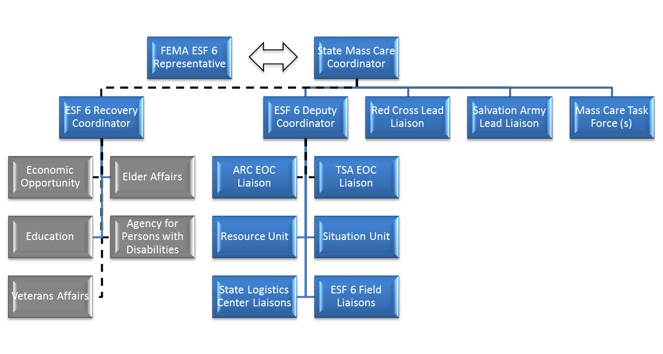

**Competency 1: Assume position responsibilities**

*Description: Successfully assume role of ESF 6 State Agency representative and initiate position activities at the appropriate time according to the following behaviors.*

**Behavior 1:** Ensure readiness for assignment.

|  |
| --- |
| **Tasks** |
| 1. Carry an electronic device that allows rapid response to alerts by the State Watch Office. 2. Arrive at the State Emergency Operations Center within one hour of an alert call |

**Behavior 2**: Ensure availability, qualifications and capabilities of resources to complete assignment.

|  |
| --- |
| **Tasks** |
| 1. Assist ESF 6 Recovery Coordinator in notifying additional agency staff if their presence is required and request that they report to the State Emergency Operations Center. 2. Verify that work station telephone and computer equipment are operationally ready and take action to correct any deficiencies. |

**Behavior 3**: Gather, update and apply situational information relevant to the assignment

|  |
| --- |
| **Tasks** |
| 1. Gather information necessary to assess the incident and determine immediate needs and actions.    * Type of incident (natural disaster or terrorism)    * Weather    * County requests for mass care or emergency assistance    * Size and density of population affected    * Extent and expected duration of loss of electrical power    * Number of shelters open and their populations    * Existence or likelihood of evacuations    * Existence or likelihood of host community operations    * Size and characteristics of vulnerable populations in the affected area 2. Obtain briefing from ESF 6 Recovery Coordinator    * Summary of incident, current activity and anticipated unit activity.    * Coordinate agency priorities, goals and objectives for ESF 6. 3. Review current and previous state and county situation reports. |

**Behavior 4**: Establish effective relationships with relevant personnel

|  |
| --- |
| **Tasks** |
| 1. Establish and maintain positive interpersonal and interagency working relationships.    * Voluntary Agency liaisons    * Other State Agency liaisons    * ESF 6 staff    * State Emergency Operations Center staff 2. Create a work environment that provides mutual respect and equal opportunity for all personnel assigned to the incident. |

**Behavior 5**: Understand and comply with ICS concepts and principles

|  |
| --- |
| **Tasks** |
| 1. Demonstrate knowledge of ICS structure, principles and positions. 2. Understand scope, roles, responsibilities, jurisdiction, and authority of responder agencies. 3. Assure execution of appropriate administrative requirements. |

**Competency 2: Communicate effectively**

*Description: Use suitable communications techniques to share relevant information with appropriate personnel on a timely basis to accomplish objectives in a rapidly changing, high-risk environment.*

**Behavior 1**: Ensure relevant information is exchanged during briefings and debriefings

|  |
| --- |
| **Tasks** |
| 1. Obtain briefing from ESF 6 Recovery Coordinator.  * Summary of incident, current activity and anticipated unit activity. * Coordinate Agency priorities, goals and objectives for ESF 6. * Receive special instructions. * Use ESF 6 Incident Action Plan board to update agency information.  1. Brief on agency activities as requested. 2. Attend planning meetings.  * Provide agency input as necessary. |

**Behavior 2**: Ensure documentation is complete and disposition is appropriate

|  |
| --- |
| **Tasks** |
| 1. Ensure that missions assigned to Agency are responded to and updated according to established guidelines. 2. Ensure that all personnel time records documenting Agency participation are completed and filed according to established guidelines. 3. Ensure that all Agency related disaster purchases are documented according to established guidelines. |

**Behavior 3**: Gather, produce and distribute information as required by established guidelines and ensure understanding by recipients

|  |
| --- |
| **Tasks** |
| 1. Ensure Agency information for the Situation Report is prepared and submitted according to established guidelines. 2. Submit reports to parent agency according to established guidelines and policies. 3. Respond to requests for information and resolve problems.  * Fulfill requests for information in a timely manner. * Follow up on all requests and problems to ensure their completion within the work period following initiation. * Advise the ESF 6 Recovery Coordinator of any political or stakeholder concerns related to multi-agency involvement. |

**Competency 3: Ensure completion of assigned actions to meet identified objectives**

*Description: Identify, analyze and apply relevant situational information and evaluate actions to complete assignments safely and meet identified objectives. Complete actions within established timeframe.*

**Behavior 1:** Administer and/or apply agency policy, contracts and agreements

|  |
| --- |
| **Tasks** |
| 1. Ensure all applicable agencies’ policies, contracts, and agreements are followed.  * State Comprehensive Emergency Management Plan ESF 6 Mass Care Annex * ESF 6 Standard Operating Guidelines * State Emergency Operations Center policies and procedures * Voluntary agencies policies and procedures * ESF 6 Supporting agencies policies and procedures |

**Behavior 2**: Gather, analyze and validate information pertinent to the incident or event and make recommendations for setting priorities

|  |
| --- |
| **Tasks** |
| 1. Assist ESF 6 Recovery Coordinator in estimating the scale of the disaster.  * Type of incident (natural disaster or terrorism) * Size of geographical area affected. * Size and density of population affected * Extent and expected duration of loss of electrical power * Weather * Existence or likelihood of evacuations * Existence or likelihood of host community operations * Size and characteristics of vulnerable populations in the affected area  1. Estimate resources required to conduct agency assigned tasks.  * Estimate total resources required. * Determine agency resources available and identify shortfalls. * Determine additional resources required from the State Emergency Response Team, by type and quantity.  1. Assemble incident information for use in briefings, reports and filling requests.  * Update incident information at the beginning of each operational period. |

**Behavior 3**: Make appropriate decisions based on analysis of gathered information

|  |
| --- |
| **Tasks** |
| 1. Establish Agency operational objectives in coordination with resource providers and in conformance with the state’s overall incident objectives.  * ESF 6 tasks for current and following operational period are coordinated daily. * ESF 6 operational objectives for the current period are stated in the daily situation report and for the following period in the afternoon ESF brief. |

**Behavior 4**: Take appropriate action based on assessed risks

|  |
| --- |
| **Tasks** |
| 1. Use established state emergency operations center coordination protocols and procedures to respond to requests for agency assistance from state agencies or counties    * Coordinate with ESF 6 staff at the state emergency operations center to assess the full scope of the request.    * Ensure that Agency missions assigned are responded to and updated according to established guidelines. 2. When required, use established state emergency operations center coordination protocols and procedures to request logistical support for Agency activities.    * Coordinate the request with ESF 6 staff at the state emergency operations center.    * Plan for 48 hours from time of request to actual delivery of logistical resource to requested location. 3. In coordination with the ESF 6 Recovery Coordinator, prepare and submit a federal Action Request Form for resources that cannot be met by the state.    * Quantify required resources by type and kind.    * Verify that requested resource is not available from state agencies.    * Coordinate request with the FEMA ESF 6 liaison at the state emergency operations center and/or the FEMA ESF 6 representative at the FEMA Regional office    * Coordinate reporting date, time and location of requested resources    * Use established state emergency operations center coordination protocols and procedures to produce and submit a FEMA Action Request Form to the State Coordinating Officer for approval    * Follow up on status of request 4. In coordination with the ESF 6 Recovery Coordinator, prepare and submit an Emergency Management Assistance Compact request for resources that cannot be met by the state.    * Quantify required resources by type and kind    * Verify that requested resource is not available from state agencies.    * Coordinate reporting date, time and location of requested resources    * Use established state emergency operations center coordination protocols and procedures to request resources through the Emergency Management Assistance Compact    * Follow up on status of request |

**Behavior 5**: Modify approach based on evaluation of incident situation

|  |
| --- |
| **Tasks** |
| 1. Coordinate, on an ongoing basis, with appropriate agencies to determine if additional agency resources are required to support the incident. 2. Maintain situational awareness.    * Seek out ESF 6 staff for situational updates.    * Read county and voluntary agency situation reports    * Monitor requests for ESF 6 support |

**Behavior 6**: Transfer position duties while ensuring continuity of authority and knowledge and taking into account the increasing or decreasing incident complexity.

|  |
| --- |
| **Tasks** |
| 1. Determine time of transfer, with ESF 6 Recovery Coordinator and your replacement. 2. Ensure that replacement is properly briefed on incident status, priorities, and assigned agency missions. |

**Behavior 7**: Plan for demobilization and ensure demobilization procedures are followed

|  |
| --- |
| **Tasks** |
| 1. Demobilize incident resources by predetermined priorities or as work progress dictates.    * Priorities are coordinated, when appropriate, with ESF 6 staff.    * Ensure Agency priorities are incorporated into the ESF 6 demobilization plan. |