Household Disaster Feeding Operational Procedure

A State Template

Referenced documents have imbedded hyperlinks

July 10, 2012
Final

Table of Contents

INTRODUCTION 3

Purpose 3

Scope 3

Definitions 3
CONCEPT OF THE OPERATION 4

GENERAL 4

PHASES OF FEEDING OPERATIONS 4

STRATEGIES FOR THE LONG TERM FEEDING PHASE 5

CRITERIA FOR IMPLEMENTING HOUSEHOLD DISASTER FEEDING 5

5 STEP PROCESS FOR IMPLEMENTING HOUSEHOLD DISASTER FEEDING 6
ACQUISITION OF FOOD FOR HOUSEHOLD DISTRIBUTION 8

GENERAL 8

DONATED FOOD 8

STATE PURCHASE 9

REQUEST FOR FEDERAL ASSISTANCE 9
Preparation of an ARF for Federal mass care resources 9
Preparation of an ARF for USDA Household Commodities (TEFAP) 10

SPECIAL DIETARY NEEDS 10
ASSEMBLY OF THE FOOD BOXES 10

GENERAL 10

DONATED FOOD 11

PURCHASED FOOD 11
DISTRIBUTION OF THE FOOD BOXES 11
APPENDIX 1 – Sample Food Box Composition 13

Family Boxes - no cooking facilities (presumes no potable water/utilities) 13

Family boxes – with cooking facilities (presumes potable water/utilities) 13
APPENDIX 2 – Guidelines for Food Drives in Disaster Response 14
APPENDIX 3 – Excerpt from FNS USDA Foods Program Disaster Manual 15
APPENDIX 4 – Sample Action Request Form 17
APPENDIX 5 – Sample Layout for Multi-Line Food Box Assembly 18
APPENDIX 6 – Sample Layout for Single line Food Box Assembly 19
APPENDIX 7 –Distribution Photos 20
APPENDIX 8 – Sample Food Bank Report 21

[Note for Final Version: This document was assembled by state, local and national practioners for use as a guide and a reference]

INTRODUCTION

Purpose
This guidance document assists jurisdictions in the development of a procedure for household disaster feeding. Once developed, this procedure can be incorporated into the operational procedures of the Multi-Agency Feeding Task Force (FTF) for the jurisdiction. If required, the multi-agency feeding plan for the jurisdiction should be adjusted to incorporate new partners added as a result of the requirements of this procedure.

Scope
This Guidance Document outlines procedures for the acquisition, assembly and distribution of food items for household distribution in a disaster within the context of a Multi-Agency Feeding Task Force (FTF). The focus stresses coordination and collaboration by the various stakeholders during preparedness, response and recovery. This guidance document is only a sample for jurisdictions to consider as they establish their own procedures and they may adjust the language herein as required.

Definitions
Food Banks are nonprofit regional distribution warehouses that collaborate with networks of existing community Agencies (Community- and Faith-based organizations like pantries and soup kitchens) which conduct day-to-day food assistance activities in their respective communities.
Ad hoc locations are those which spontaneously develop as a community response to disasters.
Mobile Pantries are trucks of various types and sizes, dry and refrigerated, which deliver either pre-packed food boxes and/or individual food items to people needing food assistance in both non-disaster and disaster situations. Food Bank Mobile pantries typically distribute a combination of canned/boxed items and fresh/frozen items, not prepared foods or hot meals. (See Appendix 7 for photo examples.) Note: Some Food Banks also have the capacity for prepared meal distribution.
A pre-assembled Feeding America disaster Food Box typically contains 25 pounds of mixed food items, the equivalent of 20 meals or 1 week of meals for 1 person. In non-disaster Mobile Pantry direct distributions of individual case lot items, each individual generally receives the equivalent of a “Food Box” as defined above – at least 25 pounds of mixed food items (usually more.) For the purposes of this document, the term “Food Box” will be used interchangeably for both pre-packaged food boxes and for direct distribution of individual case lot items. The same quantities of food will be necessary to provide household disaster feeding whether as a pre-packaged food box or via direct distribution. Food Boxes are intended to provide short term assistance and/or to supplement the needs of the survivors, not to meet their complete nutritional needs.

A Meal Equivalent is defined as a USDA standard of 1.25 pounds of food per meal. The number of pounds times .8 equals a meal equivalent. [Pounds x .8 = ME]

CONCEPT OF THE OPERATION

GENERAL
When conditions warrant, the acquisition and household distribution of individual sized, as opposed to institutional sized, food items can be implemented as part of a multi-agency disaster feeding plan. A mixture of these items is provided to individuals and households to take home for preparation and consumption.

Distribution of these food supplies is performed through a combination of the existing Food Bank distribution network and activities by the American Red Cross, The Salvation Army and other non-governmental organizations (NGOs). Household Disaster Feeding is one of several strategies that can be employed during any phase of disaster feeding depending on community needs and can particularly impact the needs of vulnerable, food-insecure citizens who may have been receiving food assistance prior to the event. Distributions are typically employed during the Sustained or Long Term phases of feeding operations, although they may be employed during the Immediate phase.

PHASES OF FEEDING OPERATIONS
The Multi-Agency Feeding Plan Template and the Feeding Task Force Guidance Document can be found in the mass care folder of the document library of NVOAD.org.
Disaster feeding operations are implemented in three phases: Immediate, Sustained and Long Term. In the Immediate phase, the first 72-96 hours after initiation of the event, the local NGOs respond to the event with available local resources and contract catering. Proper planning allows the identification and marshaling of additional resources outside the affected area.

The Sustained Phase begins with the establishment of a mass care feeding infrastructure. The focus of the mass care feeding infrastructure is on the preparation and delivery of cooked meals, snacks and beverages from mobile and fixed kitchen sites (stand alone or at congregate shelters). Feeding is made available to those affected by a disaster and disaster workers immediately at the kitchen sites or the meals are prepared and transported by mobile feeding units. Household Disaster Feeding may be appropriate in the Sustained Phase for disaster survivors that do not go to shelters but instead shelter in place. Food Banks (through a network of community and ad-hoc organizations) may provide appropriately selected food for in-home consumption before cooking in the home is possible (see Appendix 1-Examples of Food Box Composition).
“The mass care feeding infrastructure is the combination of resources provided by Federal, State and Voluntary Organizations designed to deliver emergency mass feeding to those impacted by a disaster and disaster workers.” Multi-Agency Feeding Plan Template

Household distribution of food to survivors is primarily implemented when the disaster feeding operation transitions from the Sustained phase (typically dominated by field kitchens and mobile feeding) to the Long term phase, when the restoration of utilities allows the residents to cook meals in their homes. The Sustained phase of the disaster feeding operation scales back and closes once residents have the capacity to cook meals in their homes.

STRATEGIES FOR THE LONG TERM FEEDING PHASE
The FTF and emergency management coordinates closely with private sector food retail establishments to remove any obstacles to the swift reopening of grocery stores and other private sector food businesses. Once grocery stores are reopened and operational, Points of Distribution (PODs) and those portions of the mass care infrastructure in the vicinity of these businesses are either closed down or transitioned to other areas. This transition of disaster feeding resources is performed after coordination with local emergency management and with proper notice to the affected public. Grocery chains assist the FTF and emergency management in this process by identifying the locations of reopened stores.

Some NGOs have financial assistance programs to help survivors obtain food from the private sector distribution system (like grocery stores). Food assistance for vulnerable populations may also be available at Food Banks, pantries or other community-based organizations. If warranted, the State can request USDA approval to operate the Disaster Supplemental Nutritional Assistance Program (D-SNAP) in counties/parishes that have received a Presidential Major Disaster Declaration with Individual Assistance.
For a more detailed explanation of D-SNAP and the use of USDA food commodities in a disaster, consult the USDA Foods Program Disaster Manual.

The State and/or local jurisdictions will open D-SNAP sites in targeted communities when the following three criteria have been met:
- Infrastructure and, therefore, cooking capacity is available to a significant portion of the individual homes in the community,
- Grocery stores in the community are open and operational, and
- D-SNAP distribution sites in the community have been identified and approved by local officials.

USDA-FNS Headquarters has the authority to re-designate household size USDA Foods, such as TEFAP foods, for disaster feeding if certain conditions and requirements are met (see Appendix 3). USDA commodities and D-SNAP may be distributed in a given disaster area simultaneously; however, the same household may not benefit from both forms of assistance at the same time.

CRITERIA FOR IMPLEMENTING HOUSEHOLD DISASTER FEEDING
Household Disaster Feeding is a strategy best implemented and executed as part of a broader, coordinated disaster feeding plan. The effectiveness of this strategy is increased when developed and implemented by a FTF.

Jurisdictions may establish their own criteria and may utilize donated and/or purchased food items for household food distribution. Regardless of the criteria used, the decision to implement Household Disaster Feeding must be done in a timely manner and in coordination with all the agencies involved.

GUIDELINES FOR ESTABLISHING HOUSEHOLD DISASTER FEEDING
Criterion | Determining factors include | Source of Information
Commercial food distribution channels are disrupted, making it difficult for food retailers to operate | - Availability of fuel and electricity  - Availability of road network  - Availability of employees | - Utility companies  - State DOT  - Coordination with private sector
Congregate feeding is not practical, or is expected to be inadequate to meet the needs of all affected households. | - Mass care feeding infrastructure capacity insufficient for disaster feeding demand  - Limited access to the impact area | - FTF
Households are sheltering in place at home and are in need of food. | - Shelter-in-place orders issued by local officials  - Reports from local officials or assessment teams  - Reports from Community Based Organizations | - FTF  - Local officials  - Reports from State/federal assessment teams  - NGO Liaisons
The disaster feeding organization can efficiently and effectively accept, store and distribute food items to households. | - FTF established  - Disaster feeding plan developed  - Locations identified to receive the food  - Distribution mechanism (agencies, mobile pantries) identified and prepared for distribution | - FTF  - Food Banks

5 STEP PROCESS FOR IMPLEMENTING HOUSEHOLD DISASTER FEEDING
Once the jurisdiction has decided to utilize Household Disaster Feeding, the concept of the operation is implemented in 5 steps:
An Action Request Form (ARF) is a request from a state for federal assistance in a disaster.
- Determine Need
  - Type of food and amount required
  - Geographical area of distribution
- Procurement
- Assess current capacity
- Donations, purchase, ARF FEMA, ARF USDA-FNS
- Production
- Establish initial distribution date
- Timeline from ordering to output
- Where & how food boxes will be assembled
- Distribution
- Timeline (how long will distribution be needed?)
- Demobilization
- Phase-out process
Household Disaster Feeding Operations Checklist
Objective | Factors to Consider | Source of Information
Determine type of food and amount of food required | - Incident specific  - Population impacted (estimate of population sheltering in place & locations)  - Current food bank inventory (local, statewide, regional)  - Number of meals current Food Bank inventory will provide vs. number of meals FTF projects are necessary | - State EOC  - Local officials  - FTF  - Food Banks
Assess food procurement sources | - Initial production from local Food Bank inventory  - State shelf stable meals  - State purchased food  - Feeding America Network (Members/Donors)  - Other Donated Resources | - Food Banks  - FTF  - State EOC  - Feeding America  - USDA-FNS  - ESF 15
Establish production locations | - Number of food boxes Food Banks assemble and/or distribute per day with incoming resources  - Scale/location of disaster determines packing/distribution locations (in-state, out-of-state)  - Product locations (prior to shipping)  - Transportation routes  - Expanding radius for food packing/distribution centers (in-state, out-of-state)  - Assembly of boxes may not be the most expedient means of distribution. Case lot distribution (individual items) rather than pre-assembled boxes may be optimal. | - State EOC  - FTF  - Food Banks
Establish timeline to distribution | - 96+ hours (4 days) from impact entering Sustained Phase  - Status of NGO resources  - ARF preparation (est. number hours to prepare)  - ARF approval (est. number hours/days to approve)  - Order placed (est. number hours/days to place order)  - Shipment received (est. number hours/days receive shipment)  - Hours to pack boxes- if packing (est. number hours/days to pack boxes)  - Distribution (est. number hours/days to place in community for distribution) | - FTF  - Food Banks  - State EOC  - FEMA  - Community Based Organizations (agencies)
Boxes | - Contract with local/state/national provider for supply of boxes  - Order and stage supply of boxes (as needed)  - FA network member as regular supplier? | - Food Banks  - FTF  - Feeding America
Distribution | - Determine number of agencies active  - Determine number of vehicles, size and type (24 ft, 26 ft box truck, trailers, tractors, mobile pantry, refrigerated, non-refrigerated, location, etc)  - Pool vehicles from other Food Banks must have lift gates  - Capacity estimates of each type vehicle (below)  24 Ft 10 pallets (600 pre-packed 25# boxes, 15K pounds, 12K meal equivalents  26 Ft 12 pallets (720 pre-packed 25# boxes, 18K pounds, 14,400 meal equivalents  Beverage truck/Mobile Pantry 8-10 pallets (480-600 pre-packed 25# boxes, 12K-15K pounds, 9,600-12K meal equivalents)  53Ft 26 pallets (1560 pre-packed 25# boxes, 39K pounds, 31,200 meal equivalents) | - Food Banks  - Feeding America
Demobilization | - Capacity for sustained operations  - Pre-disaster operational levels  - Stores re-opened  - D-SNAP available | - Food Bank  - Community Based Organizations (agencies)  - Local public officials  - Local EM

ACQUISITION OF FOOD FOR HOUSEHOLD DISTRIBUTION

GENERAL
Food for household distribution can be acquired through donations, purchased by the state or purchased through a request to FEMA or USDA-FNS.

DONATED FOOD
Financial contributions should be encouraged in lieu of Food Drives as a primary source of community support for food assistance. Logistical challenges associated with managing spontaneous donations can create unnecessary complications for food providers while financial contributions allow responders to purchase specific items to meet the needs of the community at any given moment.

Public Information Officers should seek guidance from the FTF prior to issuing media releases regarding specific types of resources needed (food, volunteers, etc.) In the event food drives are determined by the FTF to be necessary and appropriate, see Appendix 2 - GUIDELINES FOR FOOD DRIVES IN DISASTER RESPONSE for assistance in managing food drives. The public may be directed to the National Feeding America Food Bank Locator (links to http://feedingamerica.org/foodbank-results.aspx) to find the nearest regional Food Bank.

STATE PURCHASE
A state purchase of food for household distribution may be eligible for reimbursement under the Stafford Act. See Appendix 1 for recommended food items for purchase. Purchased items may vary depending on availability; however, food purchases should conform to the following broad categories:
- 30% canned meats/entrée items
- 25% canned vegetables
- 25% canned/dry fruits, puddings
- 15% carbs (cereal, granola/cereal bars)
- 5% shelf stable milk, juice

REQUEST FOR FEDERAL ASSISTANCE

Preparation of an ARF for Federal mass care resources
The FTF should closely monitor availability of local and state resources to determine whether Federal Assistance will be necessary to meet the needs of survivors. Preparation of an Action Request Form (ARF) should be made as quickly as possible due to the shipping and assembly time required prior to food distribution. Timelines are incident specific and dependent on factors like product availability/location, transportation routes, location of packing site, etc.
The FEMA Action Request Form (ARF) form to request federal assistance can be found at http://www.fema.gov/library/viewRecord.do?id=2750.

The ARF process may differ somewhat, depending on the jurisdiction in which it is used, but generally should follow these basic steps with regard to federal ESF-6 requests:
- Declared State completes ARF in coordination with FEMA Regional partners
- State approving official signs ARF, thereby providing official approval of the request
- State forwards ARF to FEMA Operations
- FEMA Operations verifies request is valid, signs ARF, and forwards to FEMA Logistics
- FEMA Logistics signs off on ARF indicating whether or not they can support the request
- FEMA Operations then submits ARF to the FEMA ESF-6 Mass Care Group at the field office for action
- Copy of signed ARF is delivered back to the State (See Appendix 4 for sample ARF.)

Preparation of an ARF for USDA Household Commodities (TEFAP)
FNS-USDA Headquarters has the authority to re-designate household size USDA Foods, such as The Emergency Food Assistance Program (TEFAP) foods, for disaster feeding if certain conditions and requirements are met. The State Distributing Agency for TEFAP should be included on the FTF and consulted regarding the availability of TEFAP foods and conditions under which such foods might be made available for disaster feeding. See the USDA Foods Program Disaster Manual for more details.

SPECIAL DIETARY NEEDS
The need to provide short term food assistance in a disaster may override special dietary considerations in some cases. However, planning to meet the special dietary needs of survivors should be a focus of FTF planning. Adjustments can be made when placing food orders and/or requesting food donations that enable providers to meet many dietary needs. For example, consideration should be given to ordering/requesting low sodium and low sugar items in order to meet the special dietary needs of individuals with diabetes, high blood pressure or heart disease. Food Banks/Agencies should call attention to populations with special dietary needs - communities with high populations of seniors, children, and specific ethnic/religious groups - when requesting resources.

ASSEMBLY OF THE FOOD BOXES

GENERAL
Contents for Household Food distribution are dictated by available inventory (see Appendix 1 – Sample Food Box Composition). This list was developed to provide guidance on the most desired/available products and to conform to a 25 pound box size. Items may vary depending on availability. Common items may be substituted within the general categories (for example, peas instead of green beans). Additional items can be added when potable water and utilities are available. The addition of a trained dietician to the FTF can aid in the selection of appropriate food items for substitution.

The box with contents should weigh approximately 25-26 pounds for ease in handling by recipients. All packing boxes (particularly for donated items) should be sturdy and closed so that they may be stacked on pallets and shrink-wrapped prior to shipment to the impact area. Boxes should be marked with the date packed (facing out so that it is readily visible) to assure First In-First Out (FIFO) distribution. Appendix 4 and Appendix 5 provide layout guidelines for space requirements for food box assembly.

Recommended packing instructions for food boxes:
- Layer 1(bottom of the box) canned goods
- Layer 2 boxed/bagged items
- Layer 3 (top layer) snacks, powdered drinks
- Paper goods and/or personal care items may be added if space is available or packed in a second box.

Note: Assembly of 25 pound food boxes may not always be the most expedient means of distribution. In some circumstances it may be more effective for Food Banks/agencies to distribute items directly to individuals from case lots rather than from pre-assembled boxes.

DONATED FOOD
Donated food items should be sorted prior to boxing and shipping to the impact area. Feeding America Food Banks can provide guidance and assistance on food industry standards for use of donated food items, including matters related to sanitation, product integrity or dating issues (expiration or “best if used by” dates.)

PURCHASED FOOD
Product selection is more of an option when purchasing items than when using donated items. Appendix 1- Sample Food Box Composition provides guidance on the most desired products for purchase. Substituting common items based on availability or for geographical/regional preferences is acceptable. Preference should be given to purchasing low sodium/low sugar items to accommodate common dietary concerns (diabetes, heart disease). Special Dietary Needs Boxes may also be developed to accommodate ethnic/religious requirements.

Checklist for Selecting Location for Assembly of Food Boxes
 | Determining factors | Source of Information
Facility | - Dock doors (ideally truck high)  - Capacity to receive food in multiple pallet quantities  - Pest free and adequate for food handling | Food Banks  State Food Bank Association (where available)  Emergency Management
Supplies | - Boxes  - Box tape  - Tape guns  - Permanent markers  - Pallets  - Shrink wrap | Local vendors
Equipment | - Forklifts  - Pallet Jacks  - Dock plates | Local vendors  Donations Coordinator
Staffing/Volunteers | - Trained equipment operators  - Trained Food Safety supervisor (when handling donated foods) | Volunteers Coordinator

DISTRIBUTION OF THE FOOD BOXES
The decision about when and where to start or end distribution of Food Boxes is a community decision, often with political implications. When making the decision, consider input from mass care voluntary agencies like the American Red Cross or Salvation Army, Food Banks, community based organizations, elected officials, and Emergency Management officials.

Food Banks and other community based organizations providing household food distribution should provide clear guidance to Emergency Managers and elected officials on the capability for sustained operations and recommendations on when to scale back to pre-disaster operational levels.

Household Food Distribution Checklist
 |  | Source of Information
Agency Distribution | - Food Banks partner with existing agencies or, when appropriate or necessary, with ad hoc community organizations | - Mass Care Coordinator  - Red Cross  - Salvation Army  - Food Banks  - FTF
Food Bank Mobile Distribution | - Food Banks distribute into impacted communities via mobile pantry/distribution vehicles | - Food Banks
GIS support | - Locations of all food bank warehouse locations identified  - Identify primary agency locations  - Identify operational agencies/ad hoc agencies as needed/available | - EOC  - Food Banks
Shipping | - Food Boxes or case items shipped to Food Bank responsible for the impacted area  - Food Boxes or case items may be shipped directly to agency depending on size of distribution | - Mass Care Coordinator  - Red Cross  - Salvation Army  - Food Banks

Agencies involved in distribution should ensure that an accurate record of the number of boxes and other items distributed to the survivors is reported to emergency management for inclusion in daily situation reports of mass care feeding for the event. The process and manner of this reporting should be documented in the multi-agency feeding task force operational procedure or appropriate emergency operations center standard operating guide.

APPENDIX 1 – Sample Food Box Composition

Family Boxes - no cooking facilities (presumes no potable water/utilities)
Approximate box size 9x10.5x13
Ready-to-Eat items with pop top lids – pork/vegetarian beans, fruit, vegetables, stewed tomatoes
Peanut Butter
Jelly
Tuna or canned meat – such as Spam, chicken, deviled ham
UHT milk
Cereal
Crackers
Canned fruit juices
Powdered drink mix such as lemonade, Kool-Aid
Snacks-energy bars, trail mix, cookies
Paper plates, assorted flatware, napkins/paper towels, hand sanitizer, toilet tissue, trash bags
Add a manual can opener, if possible.

Family boxes – with cooking facilities (presumes potable water/utilities)
Same items as above – Add the following when cooking facility are available
Ready to Eat (RTE) meals (beef stew, chili, spaghetti rings in sauce)
Condensed Soups (Chicken Noodle, Vegetable Beef, Vegetable)
Macaroni & cheese, boxed spaghetti meal

NOTE: When purchasing food items and/or packing food boxes, substituting common items based on availability or based on geographical/regional preferences is acceptable. Purchase preference should be given to low sodium/low sugar items to accommodate common dietary concerns (diabetes, heart disease)

APPENDIX 2 – Guidelines for Food Drives in Disaster Response
GUIDELINES FOR FOOD DRIVES IN DISASTER RESPONSE

Please use the following guidelines for sorting food drive food that will then be staged and moved into the affected areas. Your adherence to these guidelines will allow the affected food banks to move the product out rapidly with confidence that they are meeting the needs of the requests they are receiving.

- Please thoroughly evaluate and sanitize each item.
- Check for any out of date codes (note “best if used by” does not mean “expired”)
- When in doubt, throw it out.
- DO NOT SORT INTO TOTES
- All products must be boxed and in manageable sizes (recommended box weight 25 pounds)
- Break down sorting into the categories below.
- Clearly label all sorted items with the category
- Place boxed items on pallets and shrink-wrap the boxes to secure them for shipment.
- Initially, please try to create mixed pallets of the high priority items to be distributed ASAP.
- When you have a complete, sorted load, email disasterrelief@feedingamerica.org with “OFFER” as the subject line for allocation and transportation assistance.

CATEGORIES TO SORT INTO:

- Pop-top, ready to eat foods HIGH PRIORITY ITEM
- Granola bars, Power bars, HIGH PRIORITY ITEM
- Meal replacement beverages (protein shakes) HIGH PRIORITY ITEM
- Baby needs (diapers, food, bottles, etc.) HIGH PRIORITY ITEM
- Personal Hygiene (feminine, tpaste, tbrush, soap) HIGH PRIORITY ITEM
- Paper products (toilet paper, napkins, plates, tissues) HIGH PRIORITY ITEM
- Canned meats (tuna, chicken, salmon, etc.)
- Canned fruit
- Canned vegetables
- Water (Consider whether to request in food drive. Typically available as part of response)
- 100% fruit juice
- Sports drinks
- Other beverages (coffee, tea)
- Canned soups and chili
- Ready-to-Eat Snacks (Cookies/sweets)
- Boxed meals (tuna helper, hamburger helper, etc.)
- Other misc. items
- Pet food (palletize separately)
- Cleaning supplies (palletize separately)
- Detergent (palletize separately)

APPENDIX 3 – Excerpt from FNS USDA Foods Program Disaster Manual
TEFAP Food Bank Disaster Response

TEFAP Feeding During Disasters
Normal TEFAP distribution offers an immediate means of providing food to those in need during an emergency or disaster. TEFAP has advantages as part of a disaster response, as it is an ongoing program with an already established distribution network, and States have discretion to determine TEFAP eligibility criteria, including income eligibility guidelines, which disaster survivors often meet. However, the USDA Foods distributed through TEFAP, are part of the State’s TEFAP allocation, and as such, are not eligible for replacement as a result of a disaster.

Household Disaster Feeding With USDA Foods

Household disaster feeding with USDA Foods takes place only as needed, requires FNS Headquarters’ approval, and comes with certain conditions and requirements that must be met. Only FNS Headquarters has the authority to re-designate household size USDA Foods, such as TEFAP foods, for disaster feeding. As a result, food banks should not distribute TEFAP foods for household disaster feeding without first working through their Distributing Agency to obtain approval via FNS Regional Office from Food and Nutrition Service Headquarters. (See page 4 for more information about Household distribution).

Prior approval ensures that conditions have been met that would provide FNS with the authority needed to replace the USDA Foods that are distributed as part of household disaster feeding. For Presidentially declared disasters and emergencies, approved disaster feeding programs are guaranteed replacement of the USDA Foods provided for disaster feeding. In situations of distress, replacement is subject to availability of funds. However, in neither case can FNS Headquarters reimburse food banks for administrative expenses associated with such Distributions

In order for FNS Headquarters to consider approval of a household disaster feeding program, the following circumstances must exist in the disaster area:
- Commercial food distribution channels are disrupted, making it difficult for food retailers to operate and SNAP benefits to be utilized.
- Congregate feeding is not practical, or is expected to be inadequate to meet the needs of all affected households.
- Households are sheltering in place at home and are in need of food.
- The disaster feeding organization can efficiently and effectively accept USDA Foods, store them, and distribute them to households.
Applications for household disaster feeding must be submitted to FNS Headquarters through the Distributing Agency and the FNS Regional Office. See Attachment 10: USDA Foods Disaster Application Template.

The application should, to the extent possible, include the following:
- A description of the disaster, emergency, or situation of distress.
- Identification of the specific areas that would be served and the number of households expected to participate in disaster feeding.
- An explanation as to why household distribution is warranted, and the anticipated distribution period.
- The quantity and types of food needed.
- Assurances that households will not receive both USDA Foods and Disaster SNAP (DSNAP) benefits, and a description of the system used to prevent dual participation.
- The method(s) of distribution available.

Food banks which have received FNS Headquarters’ approval to distribute disaster food to households are required to collect minimal household information and, if a Disaster SNAP is also operating, obtain a signed statement from each household that they are not also receiving D-SNAP benefits. Food banks are encouraged to refer all potentially eligible households to SNAP or Disaster SNAP for additional food assistance.

Requirements for distributing disaster food to households are outlined at 7 CFR 250.69 and 250.70. For more information on disaster feeding with USDA Foods, go to http://www.fns.usda.gov/fdd/programs/fd-disasters/ or contact your FNS regional office.

APPENDIX 4 – Sample Action Request Form
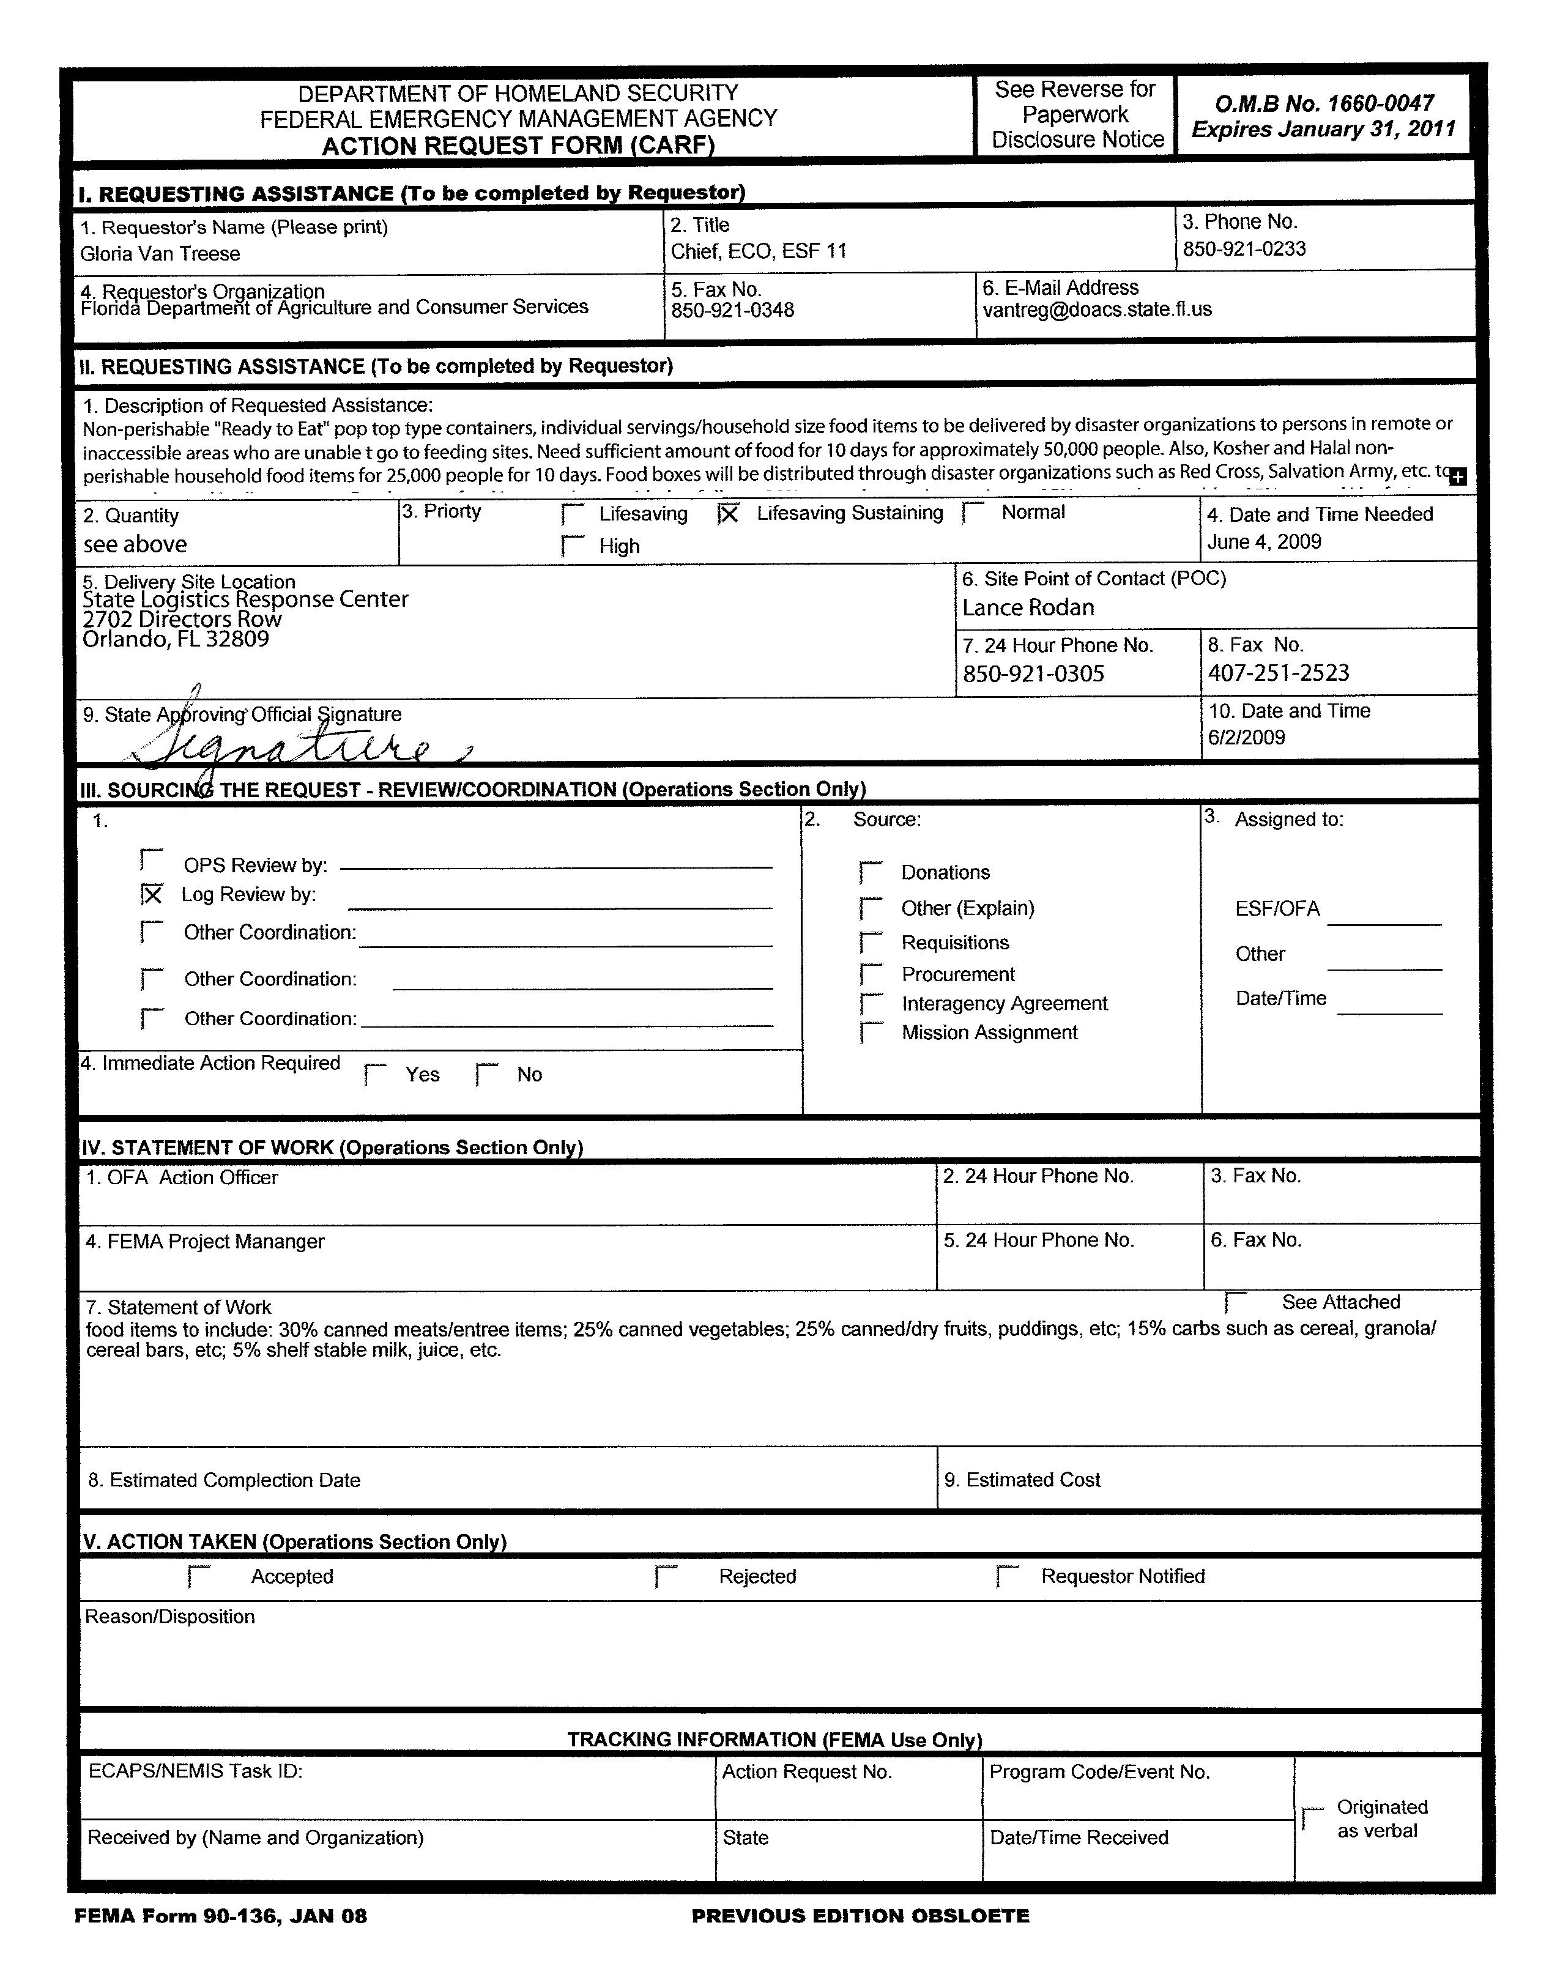

APPENDIX 5 – Sample Layout for Multi-Line Food Box Assembly
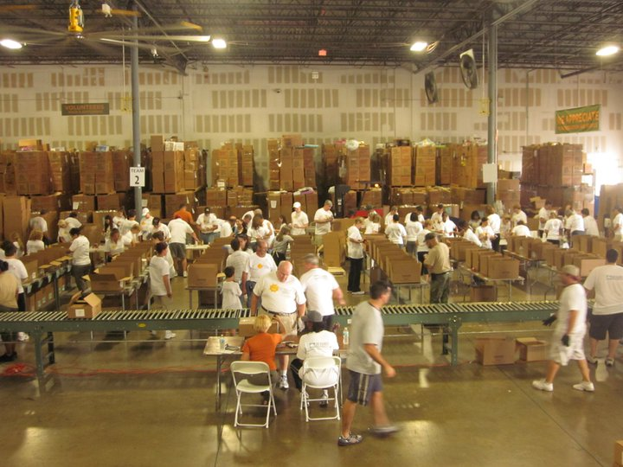

APPENDIX 6 – Sample Layout for Single line Food Box Assembly
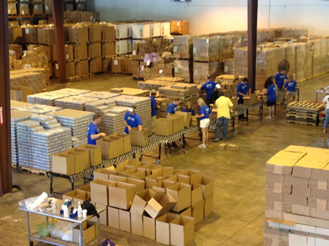

APPENDIX 7 –Distribution Photos
Box Truck Mobile Pantries (indoor & outdoor)
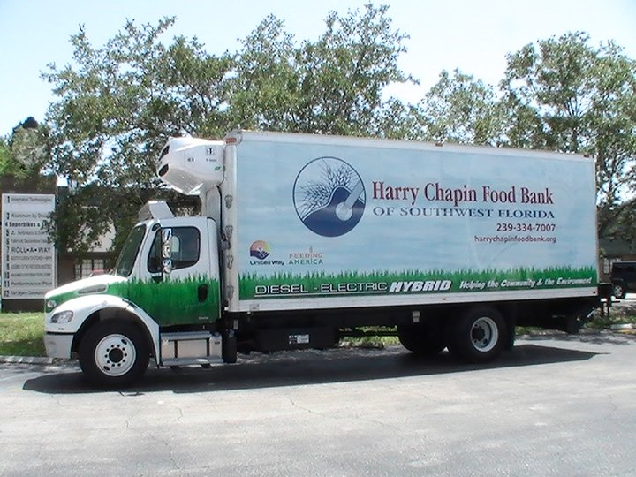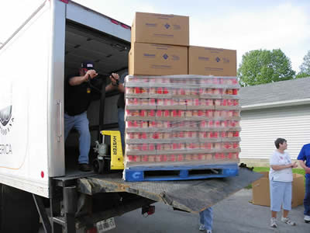
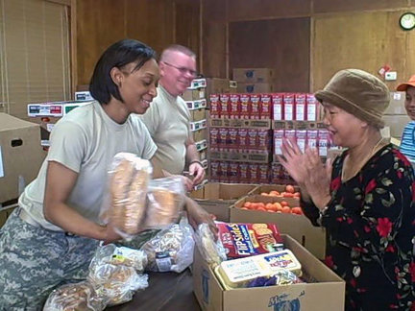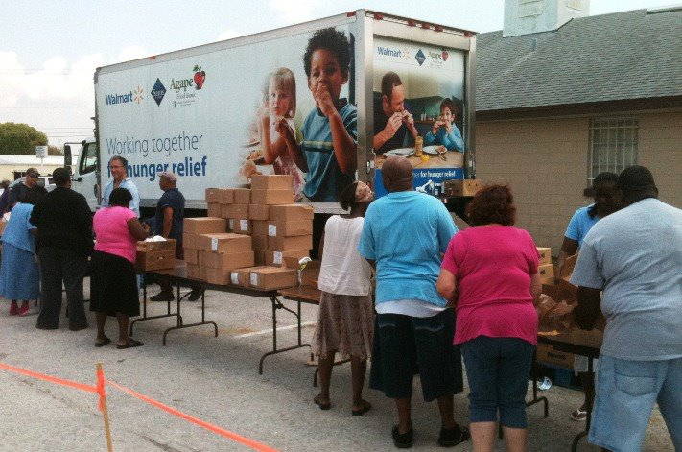

Beverage Truck Mobile Pantries (Outdoor, combination single item & pre-packed)
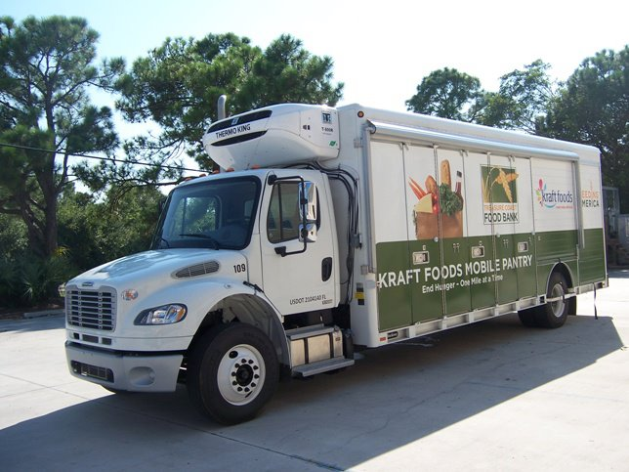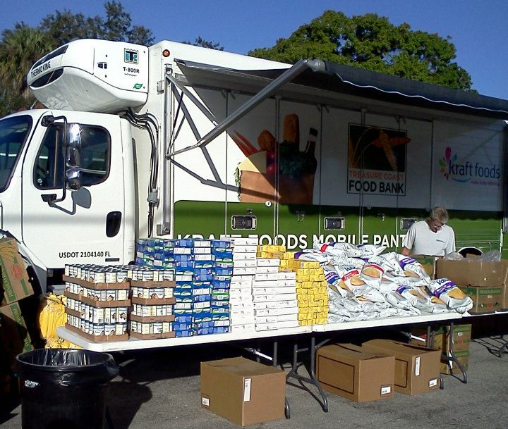
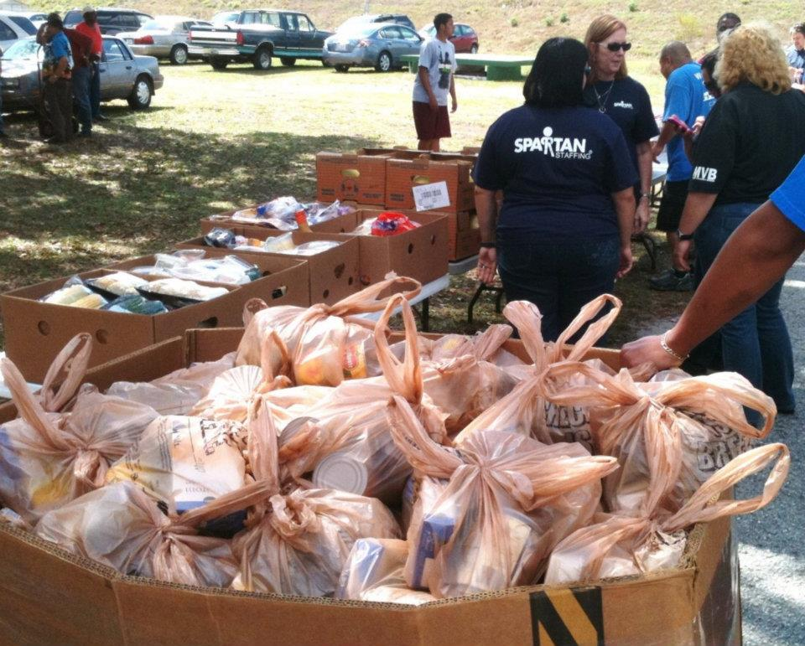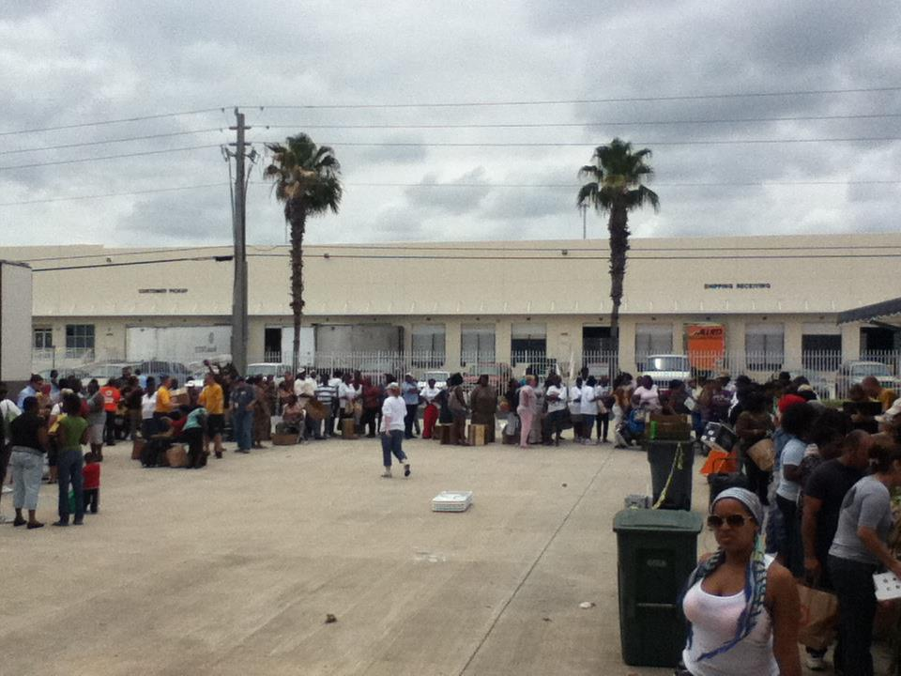

APPENDIX 8 – Sample Food Bank Report

FEEDING AMERICA DISASTER SERVICES REPORT
Event: |  |  |  |  |  | Service Date |  |  |  |  |  | As of |  |  |  |  |  | insert time
Member |  |  |  |  |  | Reporting Date
Final / Cumulative Report |  |  |  |  |  |  | Daily Report
County |  |  |  |  |  |  | Member Agency Status
Phone |  |  |  |  |  |  | Number of Agencies Active
Cell / Land |  |  |  |  |  |  | Number of Agencies Not Active
Site Address (Be Specific) |  |  |  |  |  |  | Personnel |  |  |  | Number on site |  |  |  | Hours Served
 |  |  |  |  |  |  | Local Staff
 |  |  |  |  |  |  | Network Staff
 |  |  |  |  |  |  | Volunteers
Service Report |  |  |  |  |  |  |  |  | NVOAD Partners Supported
Agencies Served (All) |  |  |  |  |  |  |  |  |  | Adventist Community Services
# of Pounds Distributed |  |  |  |  |  |  |  |  |  | American Red Cross
Food |  |  |  |  |  |  |  |  |  | Church of Latter Day Saints
Water |  |  |  |  |  |  |  |  |  | Lutheran Disaster Response
Other Beverages |  |  |  |  |  |  |  |  |  | Mennonite Disaster Relief
Cleaning |  |  |  |  |  |  |  |  |  | The Salvation Army
Paper / Hygiene |  |  |  |  |  |  |  |  |  | Southern Baptist Convention
_____________________ Other |  |  |  |  |  |  |  |  |  | United Methodist Committee on Relief
# of Shelters Supported |  |  |  |  |  |  |  |  |  | Other (List Below)
# of Distribution Sites |  |  |  |  |  |  |  |  | ▪
Product Needs (Not included in previous reports)
NUMBER OF POUNDS BEING REQUESTED |  |  |  |  |  |  |  | SPECIFIC PRODUCTS REQUESTED
Food
Water
Other Beverages
Cleaning
Hygiene
Paper
Submitted By: |  |  |  |  |  |  |  | Print |  |  |  |  | Contact Number for Data Verification
 |  |  |  |  |  |  |  | Signature |  |  |  |  | ( ) ________-_____________

