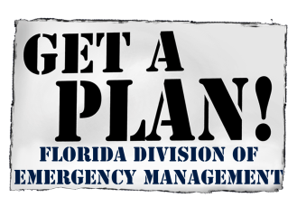
August 7, 2020

BUILDING RESILIENT INFRASTRUCTURE AND COMMUNITIES
MITIGATION GRANT PROGRAM
2020 NOTICE OF FUNDING OPPORTUNITY

Open Application Period for the Building Resilient Infrastructure and Communities
Mitigation Grant Program
Begins September 30, 2020
The Federal Emergency Management Agency (FEMA) has announced the opening of the FY 2020 Application Period for the Building Resilient Infrastructure and Communities (BRIC) program. FEMA’s Notice of Funding Opportunity (NOFO) is attached and can be found at www.grants.gov.
The Florida Division of Emergency Management (FDEM) is soliciting eligible subapplicants to prepare and submit subapplications for the BRIC grant program. All subapplications must be submitted to FDEM via FEMA’s FEMA GO grant application system on or before November 12, 2020 by 5:00 PM EST.

A schedule of webinars supporting the FY2020 Notice of Funding Opportunity is attached. For information on training and resources on FEMA’s new grant application system (FEMA GO), please visit FEMA’s website at https://www.fema.gov/grants/guidance-tools/fema-go or contact the FEMA GO Helpdesk at 1-877-611-4700 or via e-mail at FEMAGO@fema.dhs.gov.

The attached FY 2020 FMA Grant Program Fact Sheet provides Key FY 2020 BRIC Grant Program Changes and FEMA’s evaluation criteria and priorities. Detailed information regarding Flood Mitigation Assistance and application development can be found at https://www.fema.gov/grants/mitigation/building-resilient-infrastructure-communities

Contact: If you have any questions about this program, please see the attached Non-Disaster Grant Programs Project Manager Territorial Assignments Map for the contact information for the project manager assigned to your community.

Attachments:
2020 BRIC Mitigation Grant Program Notice of Funding Opportunity
2020 BRIC Mitigation Grant Program Fact Sheet
2020 BRIC NOFO Webinar Schedule
Non-Disaster Grant Programs Project Manager Territorial Assignments Map

