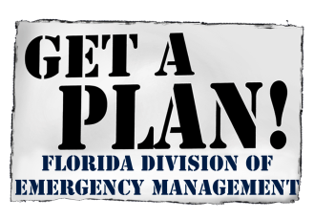
August 10, 2020

FLOOD MITIGATION ASSISTANCE GRANT PROGRAM
2020 NOTICE OF FUNDING OPPORTUNITY

Open Application Period for the Flood Mitigation Assistance Program
Begins September 30, 2020

The Federal Emergency Management Agency (FEMA) has announced the opening of the FY 2020 Application Period for the Flood Mitigation Assistance (FMA) program. FEMA’s Notice of Funding Opportunity (NOFO) is attached and can be found at www.grants.gov.
The Florida Division of Emergency Management (FDEM) is soliciting eligible subapplicants to prepare and submit subapplications for the FMA grant program. All subapplications must be submitted to FDEM via the FEMA GO grant application system on or before November 12, 2020 by 5:00 PM EST.

The attached FY 2020 FMA Grant Program Fact Sheet provides Key FY 2020 FMA Grant Program Changes and FEMA’s evaluation criteria and priorities. Detailed information regarding Flood Mitigation Assistance and application development can be found at https://www.fema.gov/grants/mitigation/floods and https://www.floridadisaster.org/dem/mitigation/flood-mitigation-assistance-program/.

A schedule of webinars supporting the FY2020 Notice of Funding Opportunities is attached. For information on training and resources on FEMA’s new grant application system (FEMA GO), please visit FEMA’s website at https://www.fema.gov/grants/guidance-tools/fema-go or contact the FEMA GO Helpdesk at 1-877-611-4700 or via e-mail at FEMAGO@fema.dhs.gov.

PLEASE NOTE: ALL PROPERTY OWNERS MUST CONTACT THEIR LOCAL GOVERNMENT
TO APPLY

Contact: If you have any questions about this program, please see the attached Non-Disaster Grant Programs Territorial Assignments Map for the contact information for the project manager assigned to your community.

Attachments:
FY 2020 FEMA Flood Mitigation Assistance Notice of Funding Opportunity
FY 2020 FEMA Flood Mitigation Assistance Fact Sheet
FY 2020 Notice of Funding Opportunities Webinar Schedule
FDEM Non-Disaster Grant Programs Project Manager Territorial Assignments Map

